Payeer for CMS WordPress 4.0 (Woocommerce)

Log in to the admin panel and on the left menu, select “Plugins”
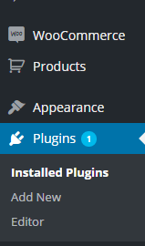

Click on “add new”
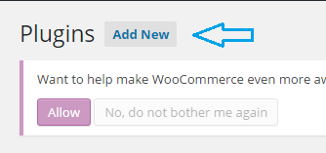

Select “download”
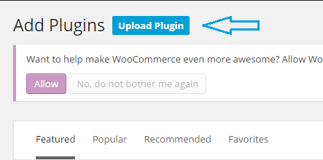

Click “choose file” and select in Windows Explorer, the archive payeer_en.zip
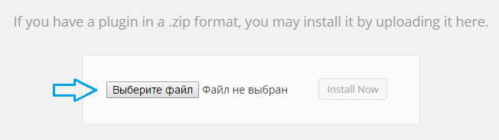

After that, click “Install Now”
Wait until the plugin will be installed and you receive a notification that the installation was successful.
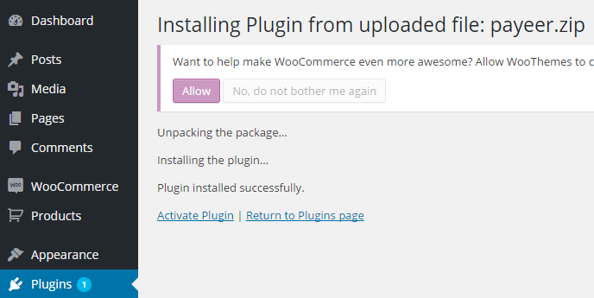

On the confirm installation, click “Activate Plugin”. Wait for activation.
After that, go to woocommerce settings.
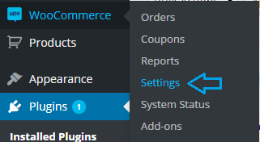

And select in the clutch “Checkout”, in the list of payment systems open Payeer
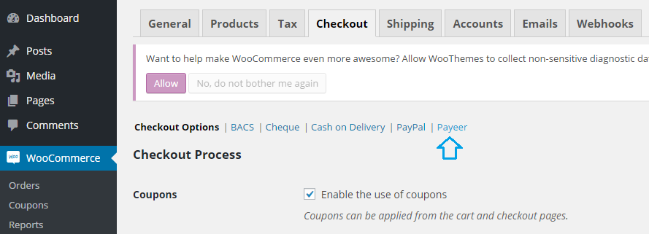

Fill in all required fields, enter the name (Payeer), select enabled for the system was available on the website.
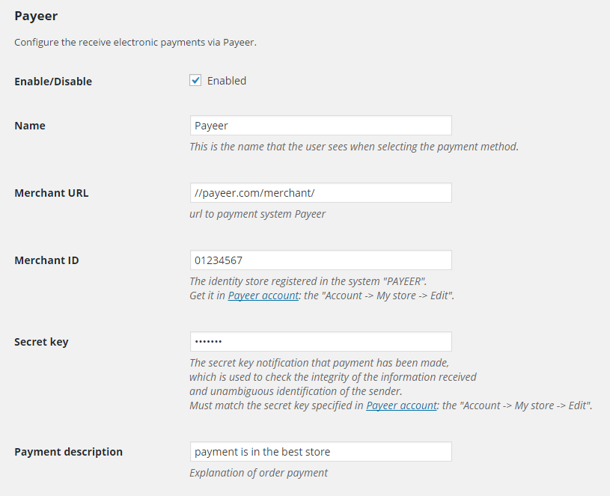

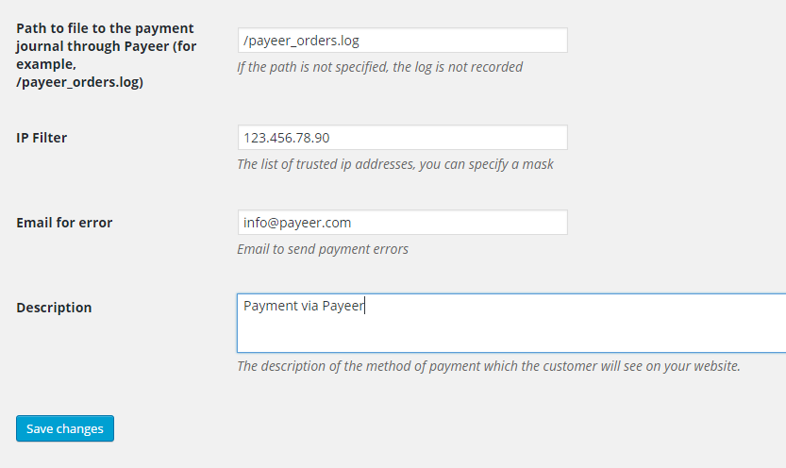

Be sure to fill in:
Merchant URL — the default way to pay //payeer.com/merchant/ (change only if an information notice from payeer.com about the change in payment URL)
Merchant ID — id of your store in the system payeer.com (you can learn in a private office)
Secret key – the secret key of your store in the system payeer.com (you specify it yourself)
Payment description — additional comment if you pay in Payeer
Path to logfile — specify the path to the file where to write the information on all payments via Payeer (if field is empty, the entry is not happening)
You can specify a list of trusted ip addresses of servers separated by commas. You can also specify a mask instead of an ip address. If the field is left empty, then checking for trusted ip addresses is not performed.

For example:
192.168.71.87, 192.165.83.17, 192.178.34.15
Or 192.*.71.87, 192.165.83.*, 192.*.34.15
Or *.*.*.* - available to all ip addresses

Enter your email address to receive notices in the event of a payment error. The letter will state the reason and basic information about the payment.

Enter the URL address in the “account Payeer → Store → Settings
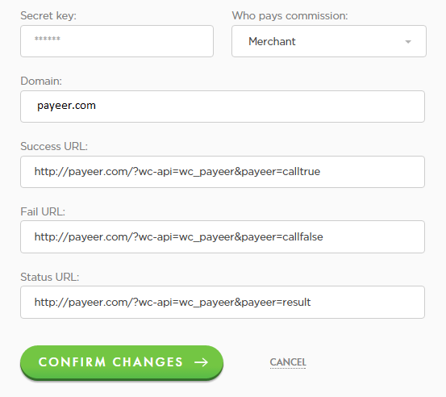

Successful payment URL
http:// *****/?wc-api=wc_payeer&payeer=calltrue
URL of unsuccessful payment
http:// *****/?wc-api=wc_payeer&payeer=callfalse
URL handler
http:// *****/?wc-api=wc_payeer&payeer=result
Where***** is your domain

After enter Master Key and click “Edit”.
Module Payeer for CMS WordPress (Woocommerce) is configured.

